**Mailing Address:**

Aftabnagar Rampura, Dhaka. Cell: 01756-501854

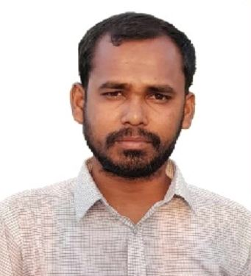**RESUME**

**Of**

**Md. Faruk Hossain**

E-Mail: [mdfarukhossein11071@gmail.com](mailto:mdfarukhossein11071@gmail.com)

**Career Objective:**

Searching Job that offers the most Congenial and rewarding atmosphere that helps bring out the best in me in order to utilize my full potentially so as to render my best effort to the institution for the growth and development and to contribute to the society as well.

**Educational Qualification:**

# Diploma Engineering in Civil Technology

Institute : Pabna Textile Engineering Institute.

Subject : Civil Technology

Result : GPA- 2.76 (Out of-4.00)

Board : BTEB

Passing Year : 2018

# Secondary School Certificate (S.S.C)

Institute : Santhia Pilot High School

Group : General Mechanics

Result : GPA- 4.62 (Out of-5.00)

Board : Technical

Passing Year : 2014

**Experience:**

* Radiant Property (Pvt.) Ltd, House -63, Block-F, Sector-01, Aftabnagar, Badda, Dhaka November 2018 to December 2023 (5 Years).
* Imperium Property Ltd, House -44, Road-04, Block-E, Banasree , Rampura, Dhaka December 2023 to Still Now.

**Computer Skills:**

* + Proficient in working with MS Word, MS Excel, MS PowerPoint, Internet Browsing, Etc.
  + Auto CAD 2D.

**Language Skill:**

* + Bengali: Fluent Reading, Writing, listening & speaking.
  + English: Fluent Reading, Writing, listening & speaking.

**Industrial Training Program:**

Successfully Completed Industrial Attachment Training Organization : Radiant Property (Pvt.) Ltd.

Address : Rampura, Dhaka.

Duration : 21/01/2018 to 19/04/2018 (03 Month)

**Interest:**

* + Reading books, Newspaper, Listening Music, Traveling.

**Personal information:**

Name : Md. Faruk Hossain

Father’s Name : Md. Shahzan Khan

Mother’s Name : Most. Forida Khatun

Date of birth : 31/12/1999

Marital Status : Married

Religion : Islam

Sex : Male.

Blood Group : (Ab+)

Height : 5 feet 5 inch

National ID No : 3304555596

Nationality : Bangladeshi (By Birth)

Permanent Address : Village: Kalaichara, P/O: Shanthia

P/S: Shanthia, District: Pabna

**Declaration:**

My dated signature certifies that all information presented on this resume is correct to the best of my knowledge.

**Signature**

**Date:**